Nail Your Java Interview
Some technical topics for Java developers may include.
- data structures
- algorithms
- object oriented programming
Java virtual machines

“ Develop once , compliance once ideology “
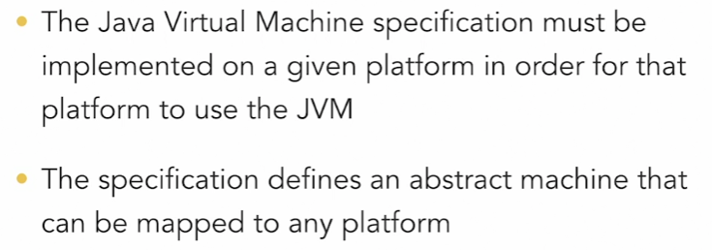
Jvm makes java be able to run in any platform
JRE - Without JRE you cant run java programs
JDK – JDK is necessary
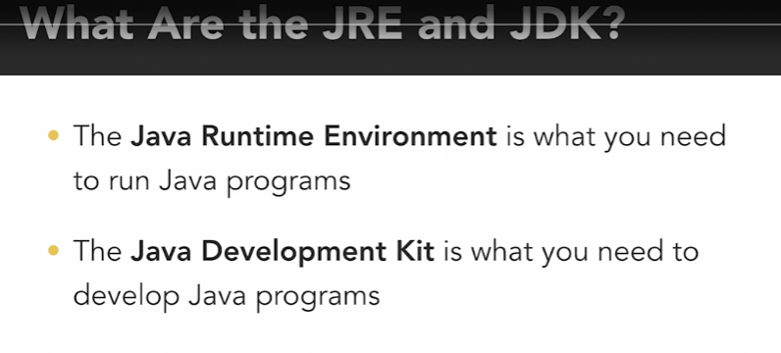
Classes are blueprints

What's the difference between static and non-static methods?
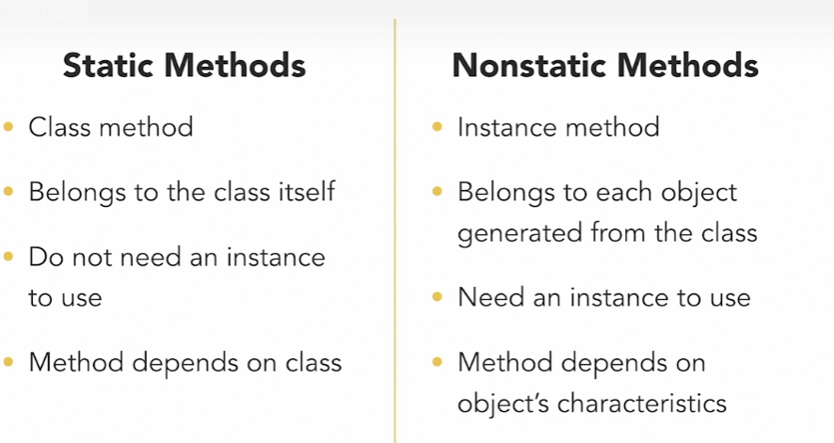
What construct do we use to define an object's properties and functionality?
- class
Correct
Classes are the blueprints we use in order to represent objects in code and defined their properties and functionality.
